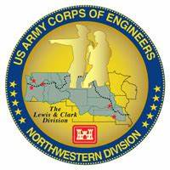
Columbia River System (CRS) Fish Facility Design Review Work Group (FFDRWG)

USACE, Portland District (NWP) and Walla Walla District (NWW)
  - August 2024 Meeting Notes
Meeting Date: August 1, 2024, 09:00-12:00
Webex: https://usace1.webex.com/join/jacob.macdonald
FFDRWG Meeting Files:
https://pweb.crohms.org/tmt/documents/FPOM/2010/FFDRWG/FFDRWG.html

FFDRWG contact list
BPA
Scott Bettin
Christine Petersen
Leah Sullivan
Ben Hausmann
Carolina Andes - CA
Josh Ashline
Tammy Mackey
NOAA
Blane Bellerud
Gabriel Brooks - GB
Trevor Conder - TC
Claire McGrath
Kelsey Swieca
Chris Magel
Kinsey Frick - KF
Dana Bethea
USFWS
Dave Swank - DS
Shelby Fowler
Joe Skalicky
States
Erick Van Dyke (ODFW)
Ben Clemens (ODFW)
C. Morrill (WDFW) - CM
Jonathan Ebel (IDFG)
CRITFC/Tribes
Tom Lorz (CRITFC) - TL
Laurie Porter (CRITFC)
Greg Silver (CRITFC)
Casey Baldwin (CTCR)
Michael Karnosh (CTGR)
Lawrence Schwabe (CTGR)
Torey Wakeland (CTGR)
Aaron Jackson (CTUIR)
Ralph Lampman (YN)
Tod Sween (NPT)
Lyman Jim (CTWS)
Jay Hesse (NPT) - JH
NPCC
Kris Homel
FPC
Erin Cooper
Noah Campbell
PSMFC
Gordy Axel - GA
Darren Chase - DC
Roger Clark - RC
Mark Leonard - ML
Scott Livingston - SL
Nicole Tancreto
CENWD
Doug Baus
Tim Dykstra
Dan Feil
Cindy Studebaker
Lisa Wright
Sean Tackley
Ian Chane
CENWP-PM
Ida Royer
Erin Kovalchuk
Mark Bierman
Brad Eppard
Nathan McClain
Jake Macdonald - JM
Jon Rerecich
David Trachtenbarg
Scott Fielding - SF
Rebecca Cates
CENWP-OD
Jeanette Flemmer - JF
Tucker Gossett
Jaselyn Owens
Eric Grosvenor
Jeff Randall
Aaron Young
David Miller
Michael Lotspeich - JDA
Laura Rickets
Robert Wertheimer
Patricia Madson- PM
Darren Gallion
Kyle Tidwell
CENWP-ENC
Adam Jones
Adam White
Brandt Bannister
Shari Dunlop
Chris Motti
Steve Schlenker
Max Wilson-Fey
Collin Porter
Dan Penn
Aaron Litzenberg
Mehdi Roshani
Cole Marfise
CENWW-PM
Chuck Barnes - CB
Ryan Ashcraft - RA
Steve Sipe
Ricardo Walker
Brad Trumbo
Liana Aker
Michael Erickson
Karen Zelch - KZ
CENWW-OD
Chris Peery
Tiffany Stoeckig-Dixon
Denise Griffith
Elizabeth Holdren
Ken Fone
Bobby Johnson
Deb Snyder
CENWW-ENC
Jon Renholds
Sean Milligan
Ryan Pestes
Travis Foster
John Lomeland
Ryan Laughery - RL

Action items from previous meetings

BON2 control section redesign PDT will provide a presentation, focused on the proposed timeline for construction within the 2024-2025 IWW at an upcoming FFDRWG, when a Contractor is chosen and their schedule can be shared (September??).

BON1 PIT Detection PDT will provide a presentation of the latest design iteration at the next FFDRWG.

FFDRWG requested an update on the new McNary turbine design (T. Lorz, email 6/21) at an upcoming meeting. The failure with the MGR at Bonneville 1 raises concerns. These were installed late 90's forward and they have now all failed in some way. Do the new turbine designs have similar weak points and have people looked at the failures in the MGR to see if similar issue may arise with the new turbines? Also, what happened to the program to move to more environmentally friendly fluids, the MGR are still petroleum based?

Jake will schedule a Webex call for interested FFDRWG and FPOM participants with relevant experience to help CRITFC/Tribes develop a video monitoring plan for when the floating lamprey collector prototype is being tested at The Dalles Dam.

NWP Topics for FFDRWG Update/Review/Coordination

NWP BON1 adult lamprey passage improvements – Erin Kovalchuk (PM), Adam White (TL), Jake Macdonald (FFDRWG)

NWP BON2 control section redesign – Erin Kovalchuk (PM), Adam White (TL), Jake Macdonald (FFDRWG)

BON2 control section redesign PDT will provide a presentation, focused on the proposed timeline for construction within the 2024-2025 IWW.

JM: Adam White gave a briefing on this project to the Bonneville Rangers yesterday. Adam confirmed in that presentation that the Design Team developed an implementable construction schedule and made it a hard constraint in the Contract bidding process. We received multiple bids, so multiple Contractors apparently agree with the Design Team that it is implementable. The Contractor’s detailed construction schedule will be made available for FFDRWG review as soon as a Contractor is chosen. Approximately one month from now.

PSMFC: moving ahead on schedule with PIT antenna design with support from BPA.

ACTION: Jake Macdonald will post “B2 Lamprey – Plans for Advertisement.pdf” to FFDRWG website.

NWP TDA adult lamprey passage improvements – Erin Kovalchuk (PM), Adam White (TL), Jake Macdonald (FFDRWG)

USACE Fish Field Unit began trap and haul of lamprey on Monday, hauled 9 fish on day 1, 26 fish on day 2. Lamprey are being released at Avery Park.
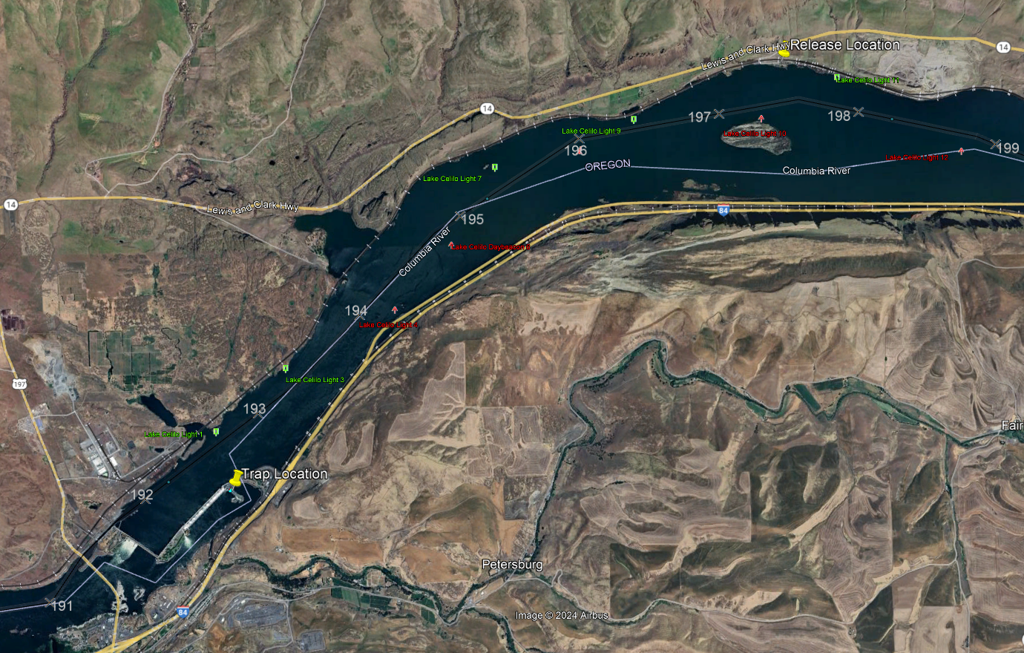

KF: Any genetic or biometric testing of hauled fish? No. We are scanning for PIT tags, but minimizing handling during the passage process.

NWP JDA adult lamprey passage improvements – Erin Kovalchuk (PM), Adam White (TL), Jake Macdonald (FFDRWG)

Plumbing issues. Will be resolved soon.

NWP BON1 PIT Detection – Mark Bierman (PM), Jeanette Flemmer (FFDRWG)

Gordy AxelPSMFC

PSMFC team provided a presentation of the latest design iteration.

Front and side view of the detection fields (yellow blobs). Front view is deceiving, side view shows complete coverage of the water column.
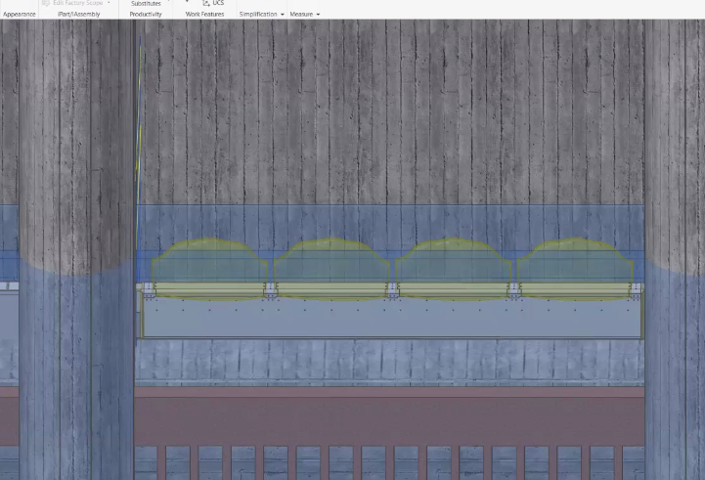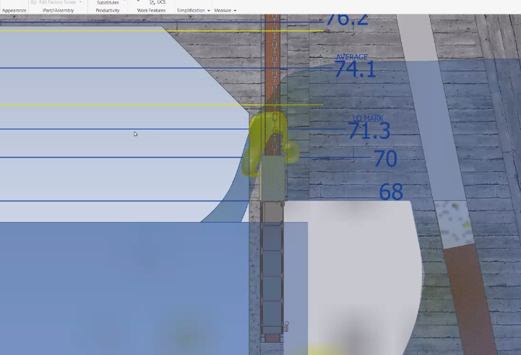

Location of gate 1B along the powerhouse.
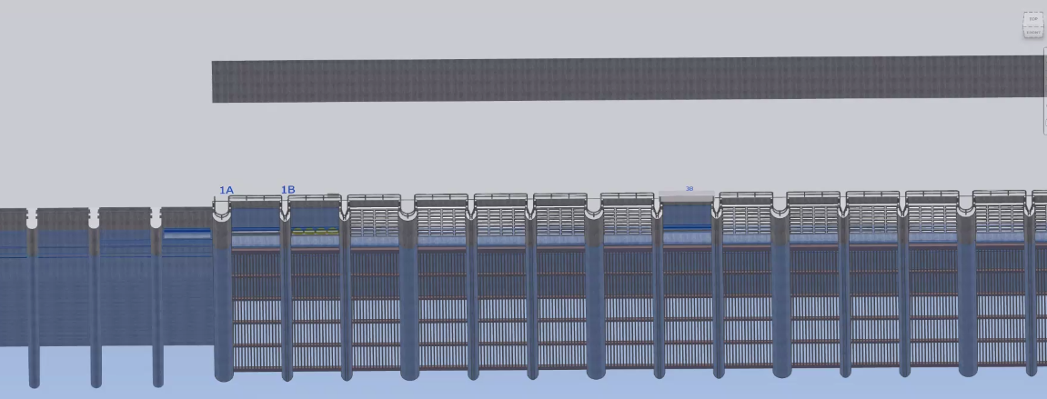

GB: expecting a boost in overall BON detections of about 0.8%, according to the 2018 alternatives analysis.

CM: Applications for McNary? GB: May be possible to design something for McNary gates. Development and design would take several years.

TC: Any plans for Didson or other monitoring to validate detection efficiency?

TL: When will it be installed? GB: planning for this winter.

GB: This will be the only year-round juvenile PIT detector in the whole system.

CA: What is the maintenance tail going to be for these antennas? SL: Very little maintenance, if any.

ML: antenna will be installed on a spare weir and swapped out in less than a day.

ML: showed all the rounded corners and other fish passage features.

NWP floating adult lamprey trap for tribal translocation (*partner project; not a USACE design) – Ralph Lampman (TL), Jake Macdonald (FFDRWG)

Tribal partners are preparing to begin testing at the Bonneville Hatchery next week (8/7)

NWP BON Spillway rock mitigation – Captain Marie Adams (PM), Adam Jones (TL), Scott Fielding (FFDRWG)

No update this month.

TL: request an update on project progress next month. Is it moving forward?

ACTION: Scott Fielding will coordinate an update on BON Spillway Rock Mitigation project at an upcoming FFDRWG meeting.

NWP TDA Backup AWS debris management – Captain Marie Adams (PM), Mehdi Roshani (TL), Jon Rerecich (FFDRWG)

No update this month.

ACTION: Jon Rerecich will coordinate an update on TDA Backup AWS debris management project at an upcoming FFDRWG meeting.

NWW Topics for FFDRWG Update/Review/Coordination

NWW IHR Turbine Cooling Water Exclusion - Karen Zelch (PM), Chuck Barnes (Bio)

Awarded to Knight Construction. Installing in unit 6 in October.

NWW MNA Turbine Replacement Design – Jean Desjarlais (PM), Jon Renholds (TL)

Slot filler final design out for FFDRWG review now.

ACTION: Jon Renholds will provide an update on the new McNary turbine design and answer questions at an upcoming FFDRWG. Jon’s update will address the ways we are learning from the past (recent B1 MGR difficulties) and not repeating it, and an update on environmentally friendly lubrication technology.

NWW LLA Adult Ladder Turn Pool Gate - Greg Linklater (PM), Chuck Barnes (Bio)

Service contract awarded for materials. Project will install this winter.

NWW MCN Avian deterrence – Karen Zelch (PM)

A/E contract, to be awarded ~September. Design charette later this calendar year. ~9 month EDR process, with a recommended alternative around May-June.

NWW MNA PIT Detection – Karen Zelch (PM)

In process of setting up a design charette with the Contractor, will present alternatives to FFDRWG after design charette, sometime early next year.

NWW John Day Dam and Snake River Ladder Cooling – Karen Zelch (PM)

A/E contract, to be awarded ~September. Design charette with contractor later this calendar year. Initial concepts for FFDRWG to chew on sometime after that.

TC: Somebody in a recent meeting (SCT?) questioned whether ladder cooling was needed at JDA and left the impression it was no longer part of the project. CB & KZ: Confirmed JDA is part of the project. May be confusing that John Day ladder cooling is being coordinated through Walla Walla District with their ladder cooling projects.

ACTION: Jake Macdonald and Scott Fielding will find whoever questioned ladder cooling at JDA and left the impression it was no longer part of the project and clarify what they really meant.

Upcoming meetings and field trips

Next regularly scheduled NWW/NWP FFDRWG meeting – Thursday, September 5th @ 09:00

Send suggestions for agenda items to Jake Macdonald and Chuck Barnes.

Field trip for FFDRWG and Corps-Tribal Lamprey Work Group to see floating lamprey collector in operation.

Partial day, In-person site visit to Tanner Creek hatchery – CRITFC/Tribes will schedule when they’re ready (August-September)

